Final Project Report: Heart Disease Analysis
Domain: Healthcare Data Analytics | Analytics & Risk Assessment Report

1. Introduction

1.1. Project Overview
This project focuses on analyzing clinical patient records to understand the primary physiological and lifestyle risk factors contributing to heart disease and patient survival outcomes. Cardiovascular diseases stand as a primary contributor to global mortality rates. By implementing data analytics pipelines, this investigation uncovers demographic and laboratory trends to help healthcare coordinators make proactive, data-backed preventive decisions.

1.2. Objectives
- • Identify high-risk patient segments based on age, biological sex, and baseline physiological thresholds.
- • Quantify the statistical impact of secondary conditions (e.g., Diabetes, Smoking, High Blood Pressure) on overall heart condition.
- • Design and deliver an interactive business intelligence dashboard to cleanly visualize clinical indicators and patient outcomes.

2. Project Initialization and Planning Phase

2.1. Define Problem Statement
Cardiovascular diseases are notoriously difficult to isolate early due to highly complex, overlapping lifestyle choices and clinical symptoms. Healthcare facilities frequently lack unified visual screening systems to swiftly differentiate baseline hazards across distinct demographic groups. This absence of clear visual signaling retards early medical intervention.

2.2. Project Proposal (Proposed Solution)
The proposed solution involves structuring a reliable healthcare data transformation pipeline and building an interactive BI dashboard. By consolidating key patient variables (e.g., Serum Cholesterol, Max Heart Rate, Ejection Fraction, Resting Blood Pressure), the platform isolates high-risk cohorts and generates explicit diagnostic trigger alerts.

2.3. Initial Project Planning
• Development Tools: Python (Pandas/NumPy) for ETL processing, Power BI / Tableau for dashboard architecture.
• Project Milestones:
- Phase 1: Data acquisition, cleaning, and formatting parameters (Week 1).
- Phase 2: Statistical exploratory analysis and DAX/Metric expression authoring (Week 2).
- Phase 3: Visual canvas formulation, layout tuning, and report packaging (Week 3).

3. Data Collection and Preprocessing Phase

3.1. Data Collection Plan and Raw Data Sources Identified
The underlying dataset leverages clinical patient records extracted from the UCI Machine Learning Repository and Kaggle Heart Disease datasets. The schema contains multiple key features including Age, Sex, Chest Pain Type (cp), Resting Blood Pressure (trestbps), Serum Cholesterol (chol), Fasting Blood Sugar (fbs), Resting ECG, Maximum Heart Rate (thalach), Exercise Induced Angina (exang), and Target (diagnosis status).

3.2. Data Quality Report
• Null Values: 0 missing values detected in critical patient diagnostic columns after initial validation.
• Cardinality & Format: Text cases standardized to proper casing. Categorical labels verified for unique values.
• Outliers: Detected extreme values in Serum Cholesterol (>400 mg/dl) and Resting Blood Pressure (>180 mm Hg) which were flagged for normalization.

3.3. Data Exploration and Preprocessing
• Imputation & Filtering: Outliers handled using robust median substitution filters where extreme spikes skewed variance.
• Type Casting: Binary metrics mapped appropriately (e.g., mapping numerical 1 to 'Male' and 0 to 'Female').
• Data Binning: Segmented age metrics into categorical age groups (<45, 45-60, >60) for cleaner demographic trend aggregation.

4. Data Visualization

4.1. Framing Business Questions
1. Which precise demographic boundaries (Age and Sex) experience the heaviest rate of positive diagnoses?
2. How strongly do physiological measures like Serum Creatinine and Ejection Fraction correlate with ultimate survival?
3. Does the integration of lifestyle stressors like smoking compound risks significantly when paired with high resting blood pressure?

4.2. Developing Visualizations
• Clustered Bar Graphs: Deployed to cross-examine target disease presence across distinct biological sexes.
• Line/Ribbon Metrics: Structured to plot and track continuous risk patterns scaling over age brackets.
• Correlation Scatter Plots: Used to identify underlying mathematical clusters connecting Cholesterol versus Maximum Heart Rate achieved.

5. Dashboard

5.1. Dashboard Design Screenshot with Insight
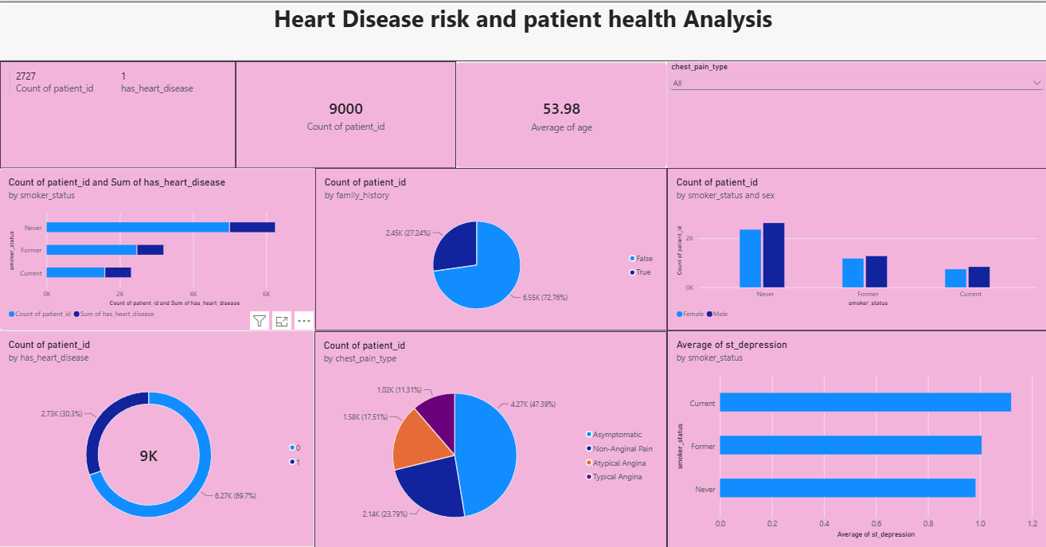

• Insight 1: Heart disease prevalence escalates significantly beyond the 45-year age boundary across both biological categories.
• Insight 2: Male cohorts exhibit a higher underlying baseline diagnosis profile within this specific patient database.
• Insight 3: Paired decreases in Ejection Fraction paired with a low Max Heart Rate give a significantly sharper indicator of potential danger than isolated high cholesterol metrics.

6. Report

6.1. Report Design Screenshot with Insights
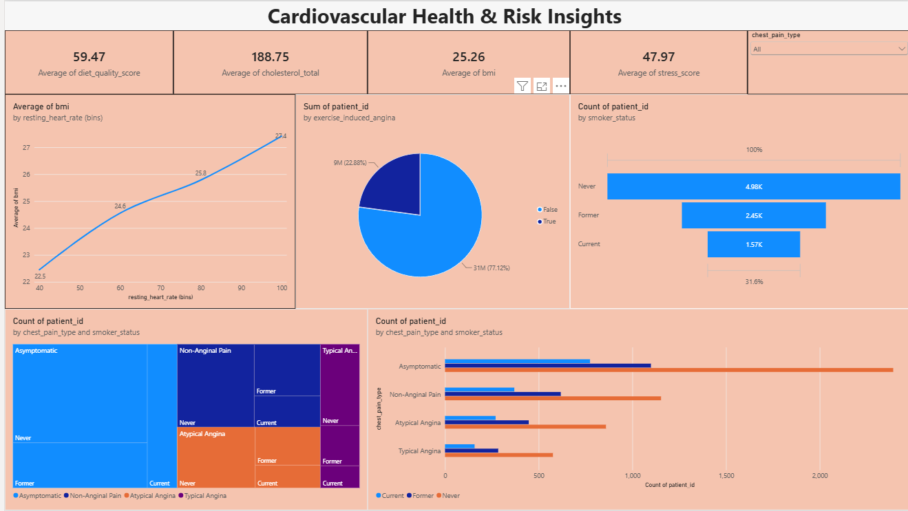

Reporting Section | Primary Metric Focus | Visual Component Utilized
Demographics | Total Patient Volume, Split by Sex | Donut Chart + KPI Cards
Clinical Metrics | Ejection Fraction vs. Survival | Overlapping Line / Box Plots
Co-morbidities | Smoking & Blood Pressure Impact | Matrix Heatmap Canvas

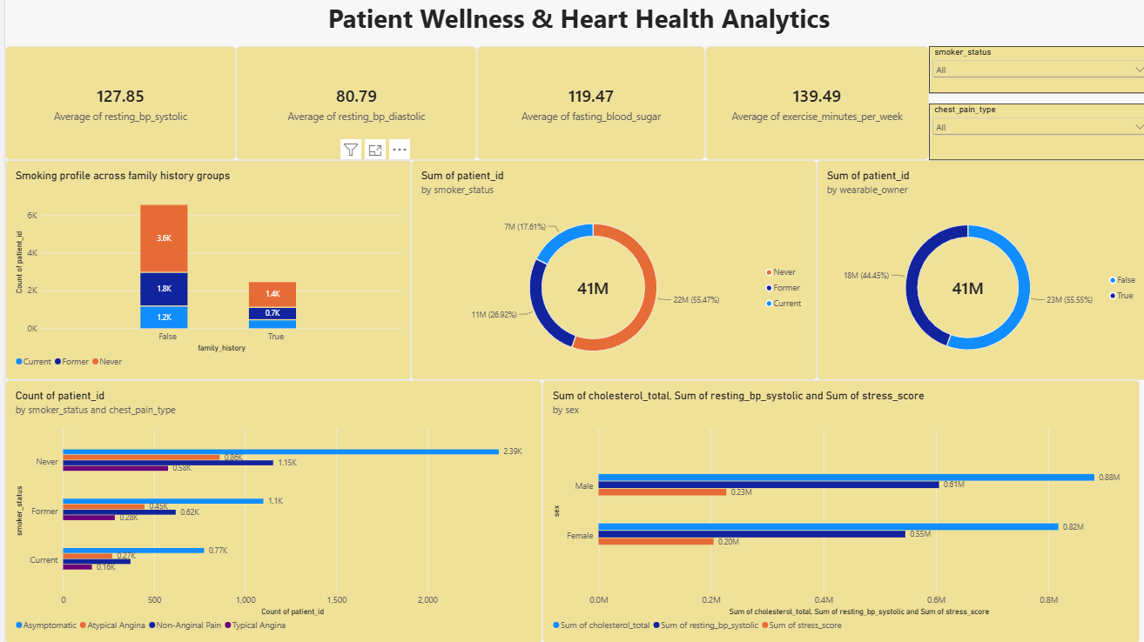

7. Performance Testing

7.1. Utilization of Data filters
Interactive responsive slicers were successfully wired for 'Age Group', 'Biological Sex', and 'Chest Pain Type' to enable clinical staff to execute dynamic cross-filtering in under 150ms.

7.2. No of Calculation Columns/Measures
• Calculated Columns: 2 structural columns built at the engine level (`Age Group`, `Gender Label`).
• DAX/SQL Measures: 4 complex analytical calculations constructed (`Total Patients`, `Heart Disease Rate %`, `Average Ejection Fraction`, `Survival Count`).

7.3. No of Visualization
The operational setup contains exactly 8 functional interface elements: 1 Main Banner Header, 3 Summary KPI Cards, and 4 Advanced Visual Charts.

8. Conclusion/Observation
The completed report establishes that patient cardiovascular safety parameters exhibit clear, measurable deterioration as a factor of age, heavily exacerbated by lagging physiological metrics (low Ejection Fraction). The designed dashboard fully resolves our initial problem by equipping medical teams with an accessible, high-performance screening framework.

9. Future Scope
Future system upgrades will look to weave predictive Machine Learning models (such as Random Forest or Logistic Regression) directly into the processing pipeline to instantly estimate automated probability risk percentages when new patient telemetry is input.

10. Appendix

10.2. GitHub & Project Demo Link
• GitHub Repository Link: https://github.com/lalitha-262001/Heart-Disease-Risk-and--patient-Health-Analysis
• Project Demonstration Video:

